Lab – Implement Local SPAN

1. Topology

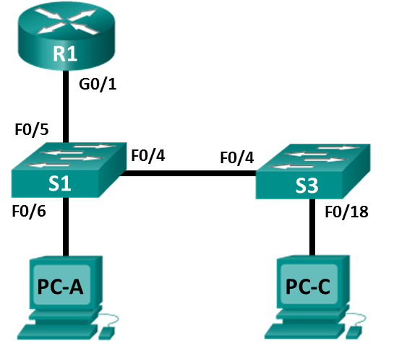

1. Addressing Table

|  |  |  |  |  |
| --- | --- | --- | --- | --- |
| Device | Interface | IP Address | Subnet Mask | Default Gateway |
| R1 | G0/1 | 192.168.1.1 | 255.255.255.0 | N/A |
| S1 | VLAN 1 | 192.168.1.2 | 255.255.255.0 | 192.168.1.1 |
| S3 | VLAN 1 | 192.168.1.3 | 255.255.255.0 | 192.168.1.1 |
| PC-A | NIC | 192.168.1.254 | 255.255.255.0 | 192.168.1.1 |
| PC-C | NIC | 192.168.1.10 | 255.255.255.0 | 192.168.1.1 |

1. Objectives

Part 1: Build the Network and Verify Connectivity

Part 2: Configure Local SPAN and Capture Copied Traffic with Wireshark

1. Background / Scenario

As the network administrator you want to analyze traffic entering and exiting the local network. To do this, you will set up port mirroring on the switchport connected to the router and mirror all traffic to another switchport. The goal is to send all mirrored traffic to an intrusion detection system (IDS) for analysis. In this initial implementation, you will send all mirrored traffic to a PC which will capture the traffic for analysis using a port sniffing program. To set up port mirroring you will use the Switched Port Analyzer (SPAN) feature on the Cisco switch. SPAN is a type of port mirroring that sends copies of a frame entering a port, out another port on the same switch. It is common to find a device running a packet sniffer or Intrusion Detection System (IDS) connected to the mirrored port.

**Note**: The routers used with CCNA hands-on labs are Cisco 1941 Integrated Services Routers (ISRs) with Cisco IOS Release 15.2(4)M3 (universalk9 image). The switches used are Cisco Catalyst 2960s with Cisco IOS Release 15.0(2) (lanbasek9 image). Other routers, switches, and Cisco IOS versions can be used. Depending on the model and Cisco IOS version, the commands available and output produced might vary from what is shown in the labs. Refer to the Router Interface Summary Table at the end of this lab for the correct interface identifiers.

**Note**: Make sure that the routers and switches have been erased and have no startup configurations. If you are unsure, contact your instructor.

1. Required Resources

* 1 Router (Cisco 1941 with Cisco IOS Release 15.2(4)M3 universal image or comparable)
* 2 Switches (Cisco 2960 with Cisco IOS Release 15.0(2) lanbasek9 image or comparable)
* 2 PCs (Windows 8, 7, or Vista with terminal emulation program, such as Tera Term)
* Console cables to configure the Cisco IOS devices via the console ports
* Ethernet and serial cables as shown in the topology

1. Build the Network and Verify Connectivity

In Part 1, you will set up the network topology and configure basic settings, such as the interface IP addresses, static routing, device access, and passwords.

* 1. Cable the network as shown in the topology.

Attach the devices as shown in the topology diagram, and cable as necessary.

* 1. Configure PC hosts.
  2. Initialize and reload the routers and switches as necessary.
  3. Configure basic settings for the router.
     1. Disable DNS lookup.
     2. Configure the device name as shown in the topology.
     3. Configure an IP address for the router as listed in the Addressing Table.
     4. Assign **class** as the encrypted privileged EXEC mode password.
     5. Assign **cisco** for the console and vty password, enable login.
     6. Set the vty lines to **transport input telnet**
     7. Configure **logging synchronous** to prevent console messages from interrupting command entry.
     8. Copy the running configuration to the startup configuration.
  4. Configure basic settings for each switch.
     1. Disable DNS lookup.
     2. Configure the device name as shown in the topology.
     3. Assign **class** as the encrypted privileged EXEC mode password.
     4. Configure IP addresses for the switches as listed in the Addressing Table.
     5. Configure the default gateway on each switch.
     6. Assign **cisco** for the console and vty password and enable login.
     7. Configure **logging synchronous** to prevent console messages from interrupting command entry.
     8. Copy the running configuration to the startup configuration.
  5. Verify connectivity.
     1. From PC-A, you should be able to ping the interface on R1, S1, S3, and PC-C. Were all pings successful? ______________

If the pings are not successful, troubleshoot the basic device configurations before continuing.

* + 1. From PC-C, you should be able to ping the interface on R1, S1, S3, and PC-A. Were all pings successful? ______________

If the pings are not successful, troubleshoot the basic device configurations before continuing.

1. Configure Local SPAN and Capture Copied Traffic with Wireshark

To configure Local SPAN you need to configure one or more source ports called monitored ports and a single destination port also called a monitored port for copied or mirrored traffic to be sent out of. SPAN source ports can be configured to monitor traffic in either ingress or egress, or both directions (default).

The SPAN source port will need to be configured on the port that connects to the router on S1 switchport F0/5. This way all traffic entering or exiting the LAN will be monitored. The SPAN destination port will be configured on S1 switchport F0/6 which is connected to PC-A running Wireshark.

* 1. Configure SPAN on S1.
     1. Console into S1 and configure the source and destination monitor ports on S1. Now all traffic entering or leaving F0/5 will be copied and forwarded out of F0/6

S1(config)# **monitor session 1 source interface f0/5**

S1(config)# **monitor session 1 destination interface f0/6**

* 1. Start a Wireshark Capture on PC-A.
     1. Open Wireshark on PC-A, set the capture interface to the Local Area Connection and click **Start**.

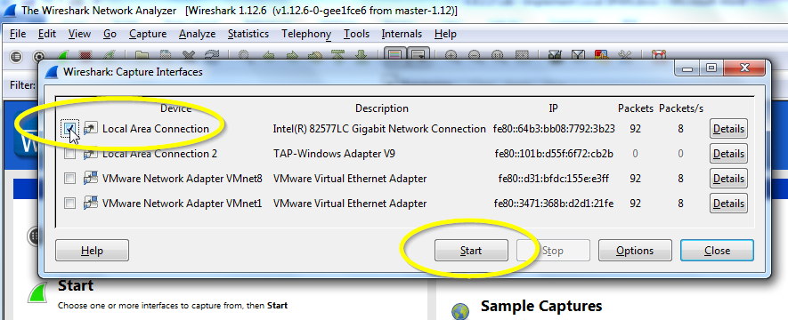

* 1. Telnet into R1 and create ICMP traffic on the LAN.
     1. Telnet from S1 to R1.

S1# **Telnet 192.168.1.1**

Trying 192.168.1.1 . . . Open

User Access Verification

Password:

R1>

* + 1. From privileged mode, ping PC-C, S1 and S3.

R1> **enable**

Password:

R1# **ping 192.168.1.10**

Type escape sequence to abort.

Sending 5, 100-byte ICMP Echos to 192.168.1.10, timeout is 2 seconds:

!!!!!

Success rate is 100 percent (5/5), round-trip min/avg/max = 1/1/4 ms

R1# **ping 192.168.1.2**

<Output omitted>

R1# **ping 192.168.1.3**

<Output omitted>

* 1. Stop the Wireshark Capture on PC-A and Filter for ICMP.
     1. Return to PC-A and stop the running Wireshark capture on PC-A.

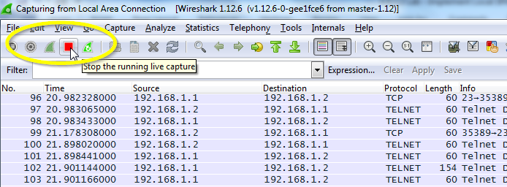

* + 1. Filter the Wireshark capture for ICMP packets.

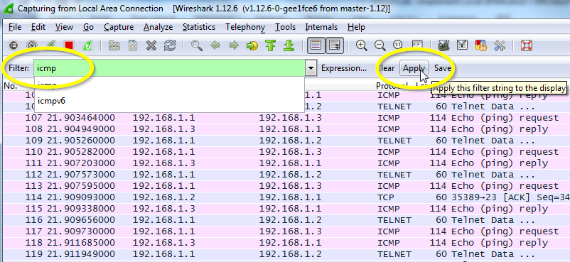

* + 1. Examine the Wireshark capture filtered for ICMP packets.

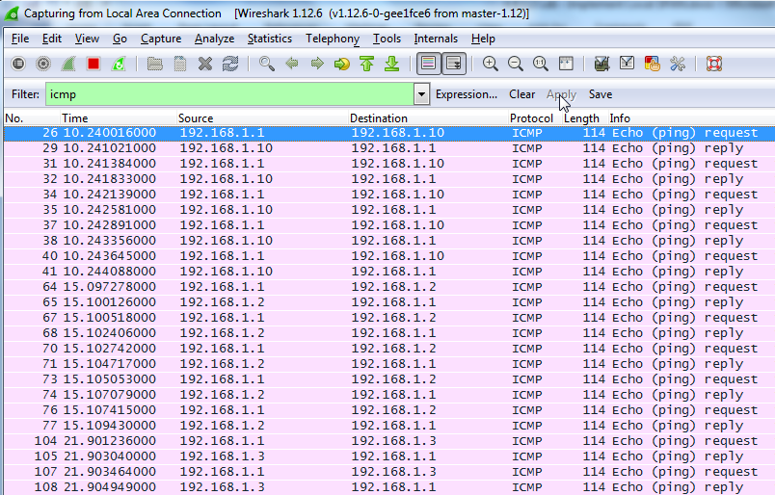

* + 1. Were the pings from R1 to PC-C, S1 and S3 successfully copied and forwarded out f0/6 to PC-A?

________________

* + 1. Was the traffic monitored and copied in both directions? ________________

1. Reflection

In this scenario, instead of using PC-A, and a packet sniffer, would an IDS or an IPS be more appropriate?

_______________________________________________________________________________________

_______________________________________________________________________________________

1. Router Interface Summary Table

|  |  |  |  |  |
| --- | --- | --- | --- | --- |
| Router Interface Summary | | | | |
| Router Model | Ethernet Interface #1 | Ethernet Interface #2 | Serial Interface #1 | Serial Interface #2 |
| 1800 | Fast Ethernet 0/0 (F0/0) | Fast Ethernet 0/1 (F0/1) | Serial 0/0/0 (S0/0/0) | Serial 0/0/1 (S0/0/1) |
| 1900 | Gigabit Ethernet 0/0 (G0/0) | Gigabit Ethernet 0/1 (G0/1) | Serial 0/0/0 (S0/0/0) | Serial 0/0/1 (S0/0/1) |
| 2801 | Fast Ethernet 0/0 (F0/0) | Fast Ethernet 0/1 (F0/1) | Serial 0/1/0 (S0/1/0) | Serial 0/1/1 (S0/1/1) |
| 2811 | Fast Ethernet 0/0 (F0/0) | Fast Ethernet 0/1 (F0/1) | Serial 0/0/0 (S0/0/0) | Serial 0/0/1 (S0/0/1) |
| 2900 | Gigabit Ethernet 0/0 (G0/0) | Gigabit Ethernet 0/1 (G0/1) | Serial 0/0/0 (S0/0/0) | Serial 0/0/1 (S0/0/1) |
| **Note**: To find out how the router is configured, look at the interfaces to identify the type of router and how many interfaces the router has. There is no way to effectively list all the combinations of configurations for each router class. This table includes identifiers for the possible combinations of Ethernet and Serial interfaces in the device. The table does not include any other type of interface, even though a specific router may contain one. An example of this might be an ISDN BRI interface. The string in parenthesis is the legal abbreviation that can be used in Cisco IOS commands to represent the interface. | | | | |